Date :21/12/22 Seat No:

…………………………………………………......

**PRACTICAL NO.1**

**Aim:** Familiarizing Quantum GIS: Installation of QGIS, datasets for both Vector and Raster data, Maps.

**Installation of QGIS –**

1. Click on Next button and continue with the installation.

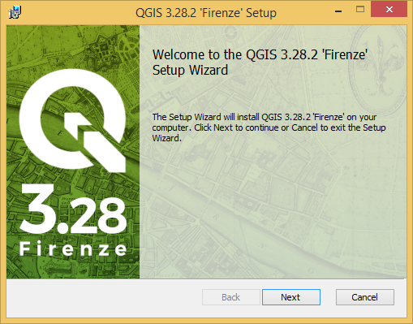

1. Please go through the license agreement and click on the button> I agree and proceed with the installation as shown in the screen.

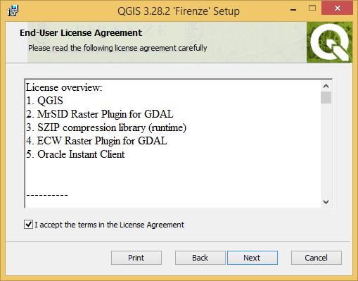

1. Select the Destination folder –

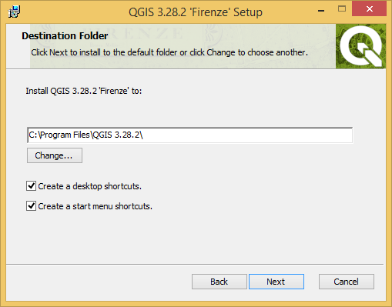

1. Click on Install –

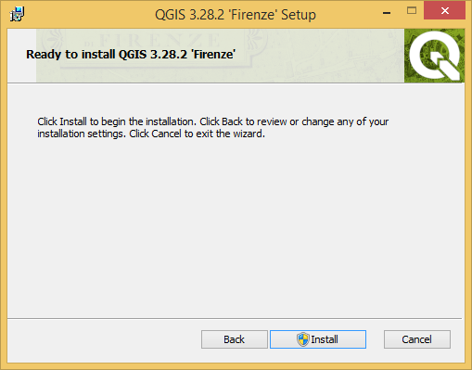

1. You will see the progress of the installation on the screen –

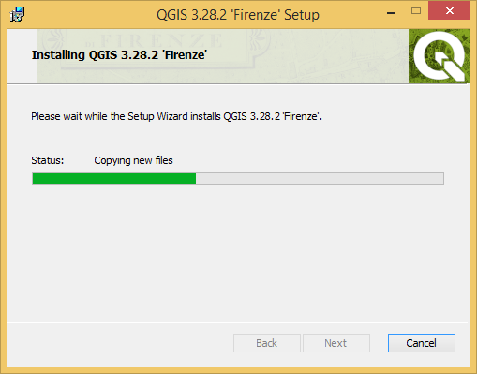

1. After the installation is completed, click on Finish –

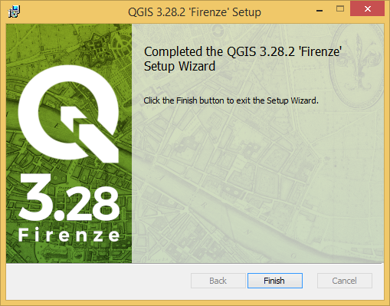

1. Run and open QGIS Desktop 3.28.2 –

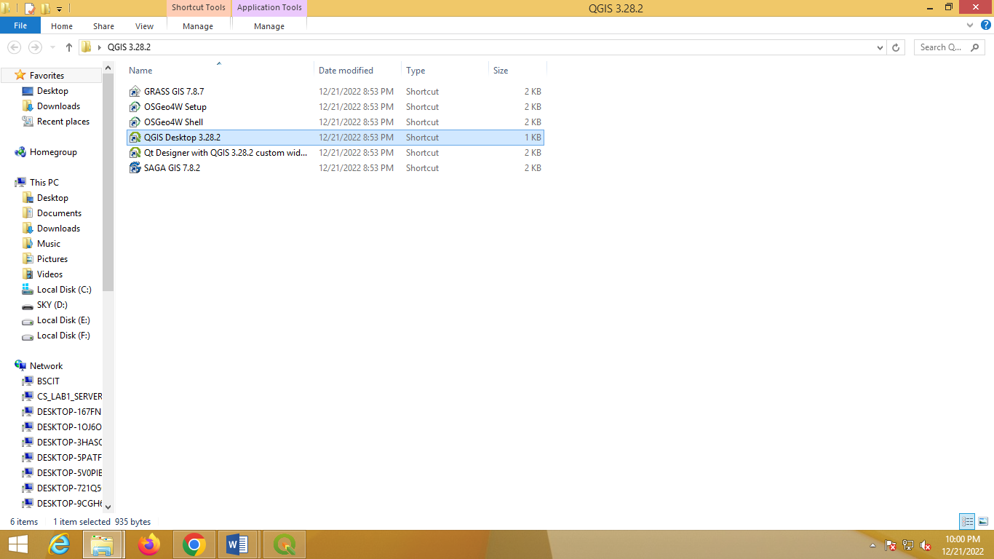

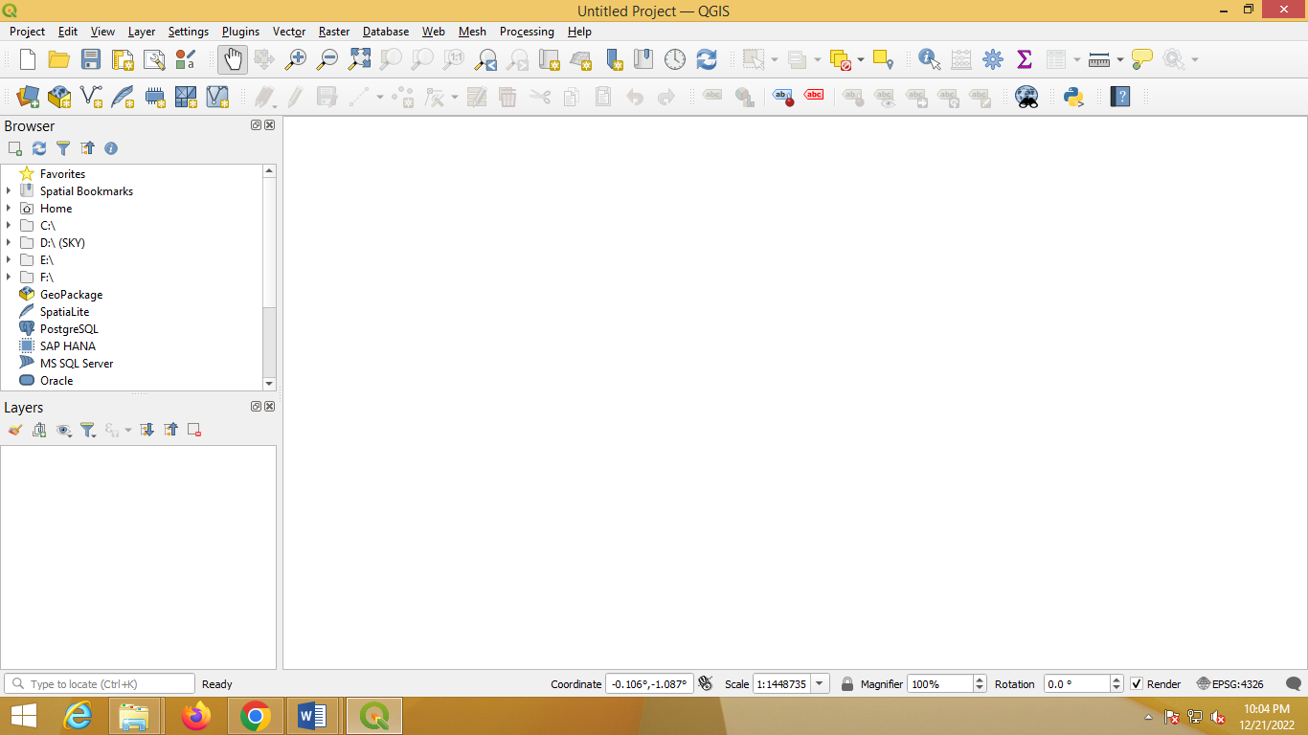

Date :21/12/22 Seat No:

…………………………………………………......

**PRACTICAL NO.1**

**Aim** :- Creating and Managing Vector Data: Adding vector layers, setting properties,formatting, calculating line lengths and statistics

**Practical –1A :- Creating and Managing Vector Data**

1. **Adding vector layer –**
2. Select **Project→New**

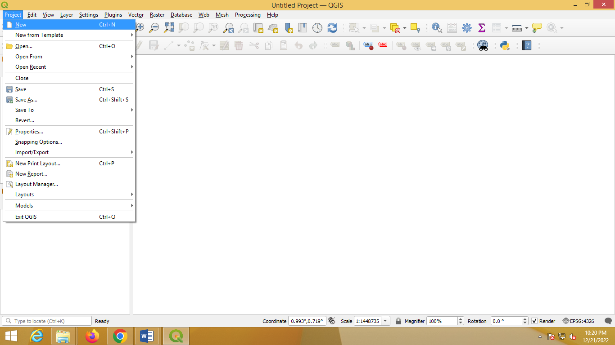

1. Select **Layer→Create Layer→New Shapefile Layer**

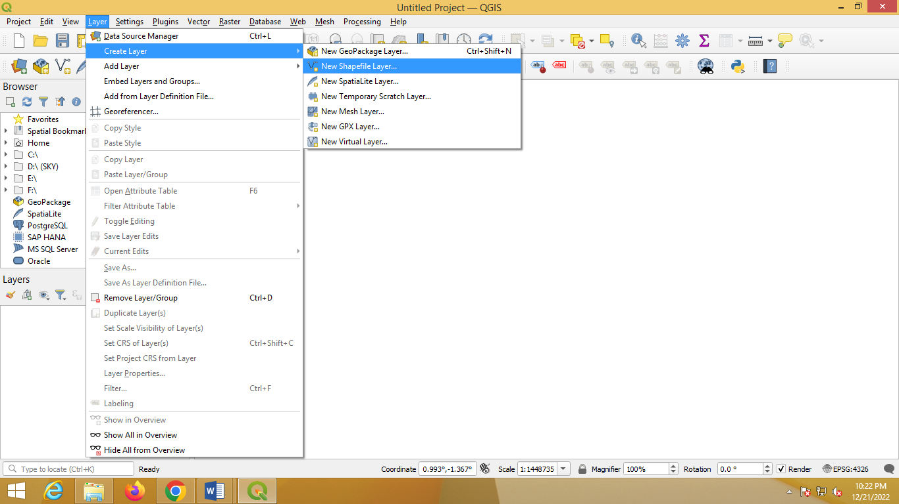

1. Following dialog box will appear on the screen. Select Polygon option from Geometry type. Select file name and location -

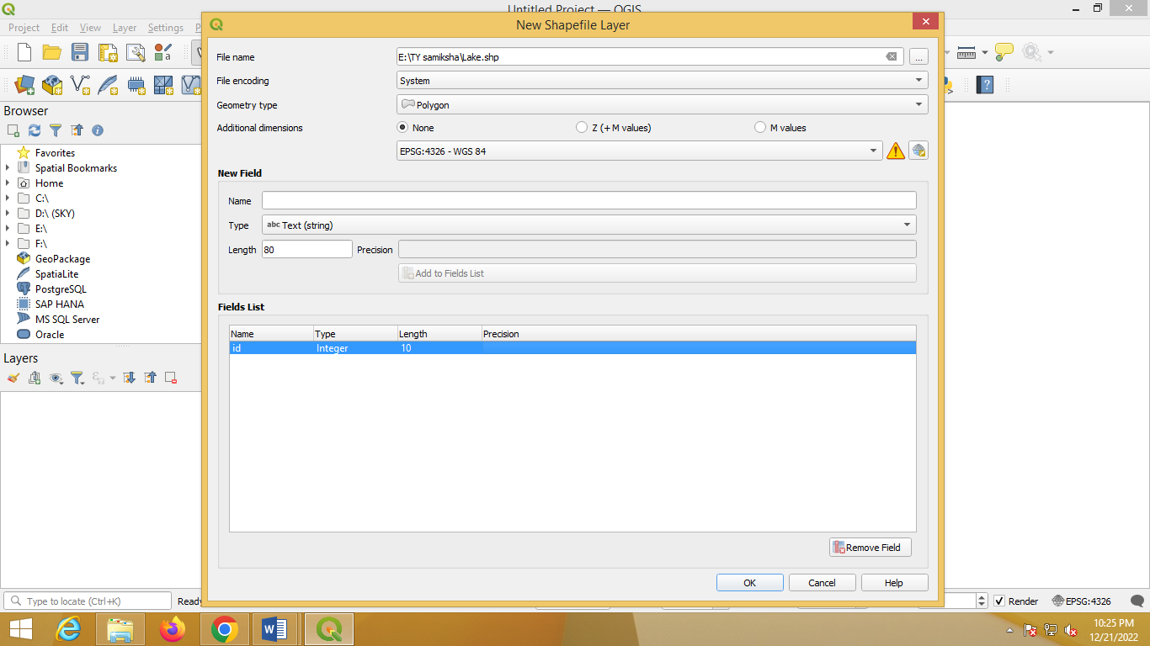

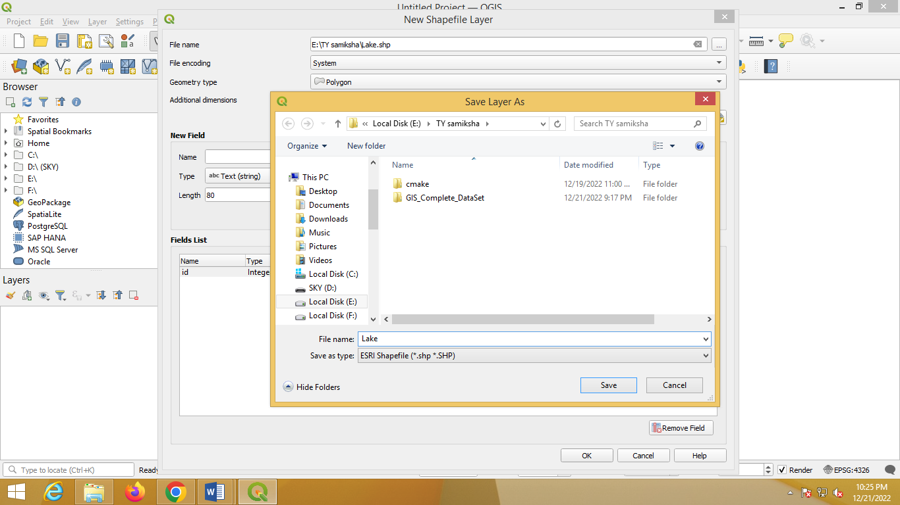

1. In field panel add attribute such as name, file type and length. Then click on Add to Fields List, then Ok -

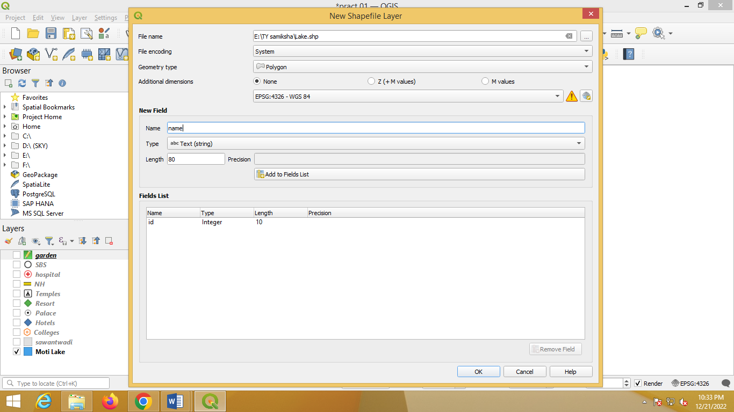

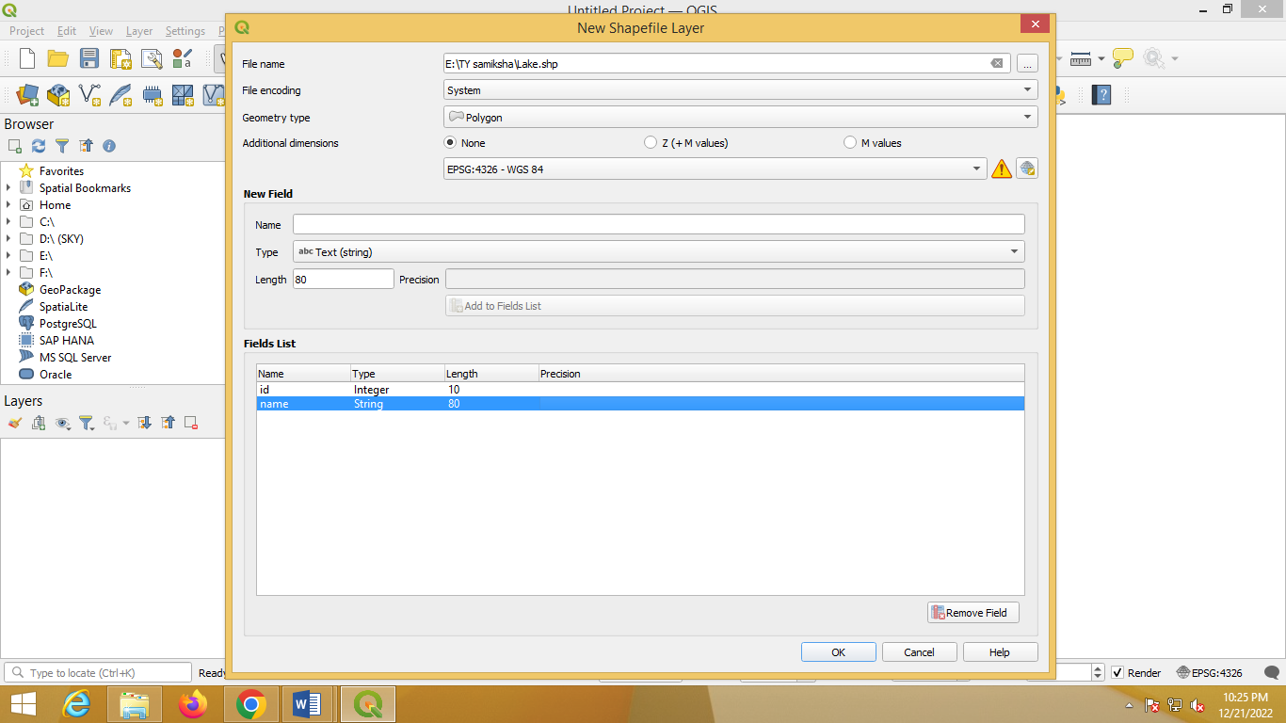

1. Click Toggle Editing Button → Click on Add Polygon →Now place the cursor at the location where you want to place the polygon. For polygon layer minimum 3 points should be selected –

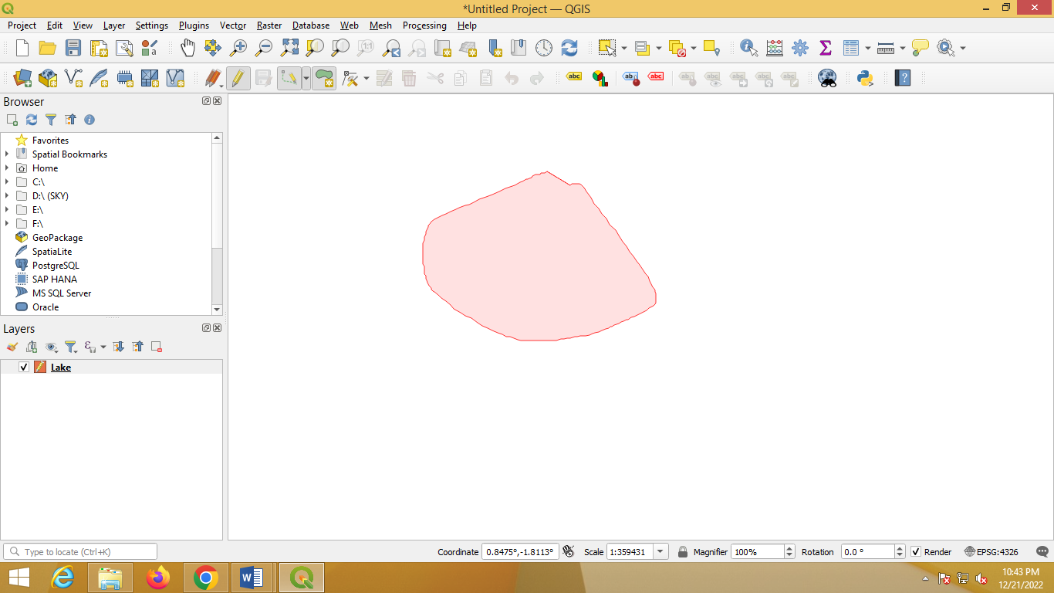

1. Save the newly added polygon as follows

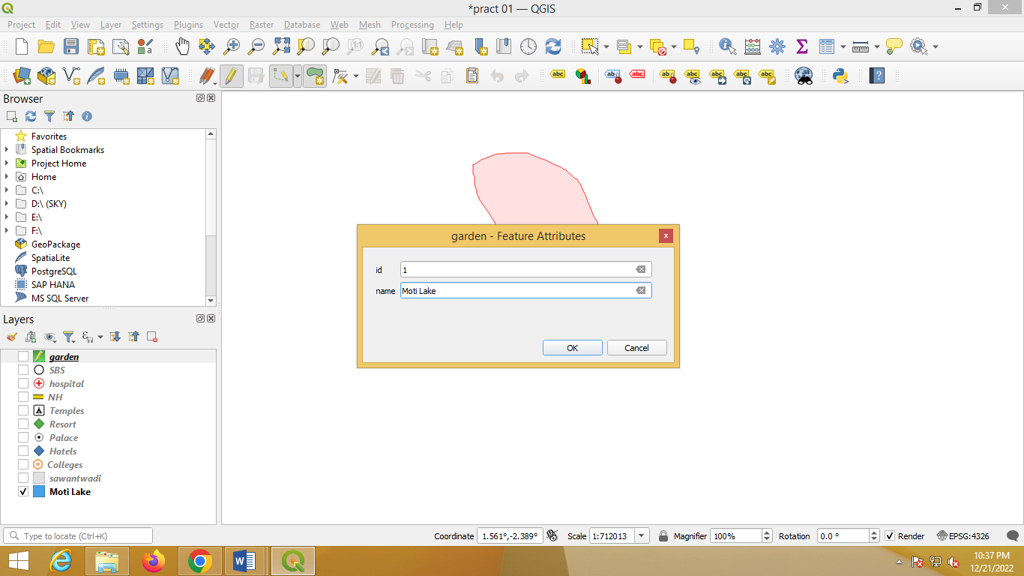

1. Set style for polygon by using property window (Right click on Lake Layer)

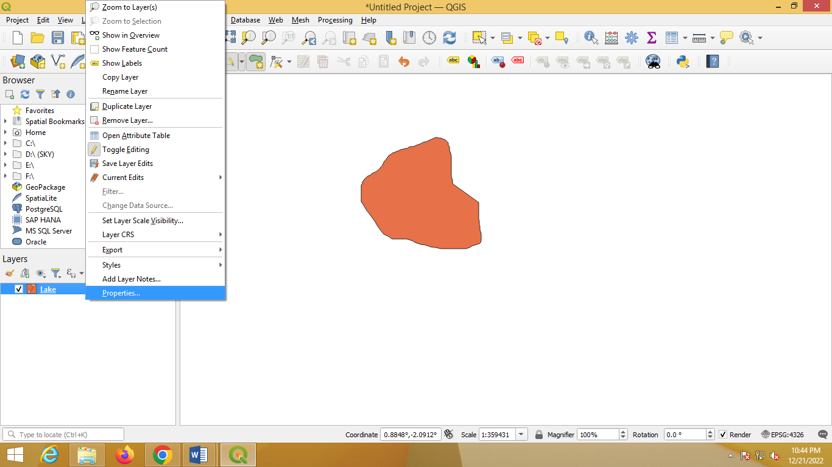

1. Following screen will appear on the screen. Select pattern as you want and click on OK.

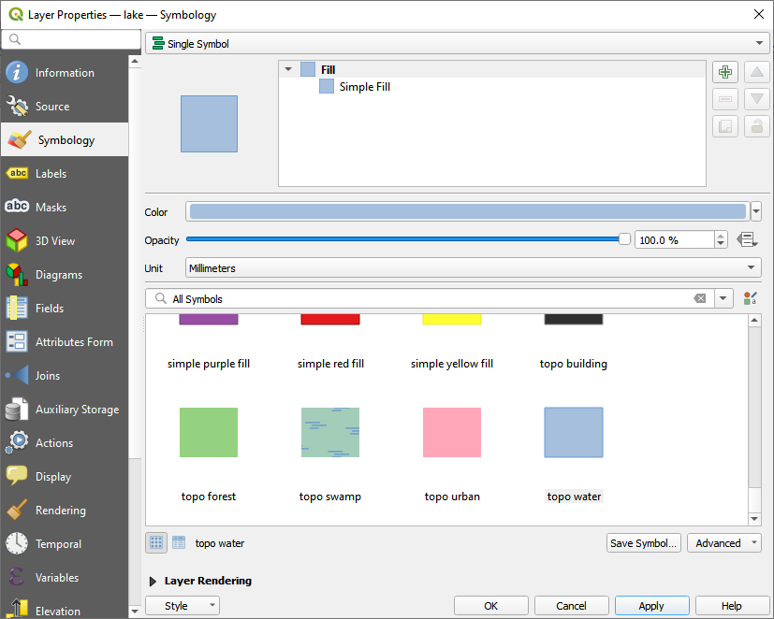

OUTPUT :-

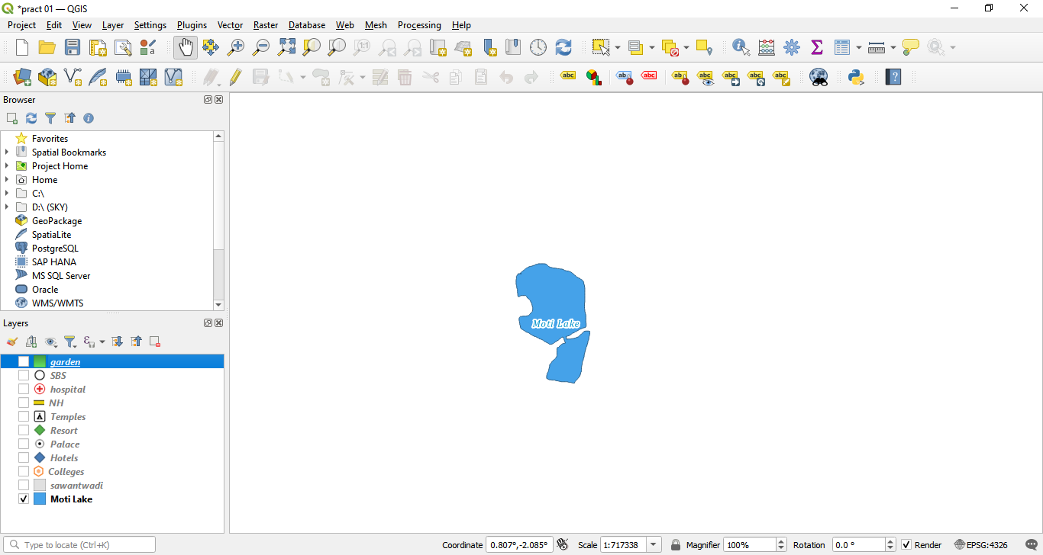

Date :21/12/22 Seat No:

…………………………………………………......

**PRACTICAL NO.1**

**Aim** :- Creating and Managing Vector Data: Adding vector layers, setting properties,formatting, calculating line lengths and statistics

**Practical –1B :- Creating and Managing line Vector Layer**

1. **Creating Line vector layer –**
2. Repeat the same steps as we have done for polygon layer -
3. Select geometry type Line -

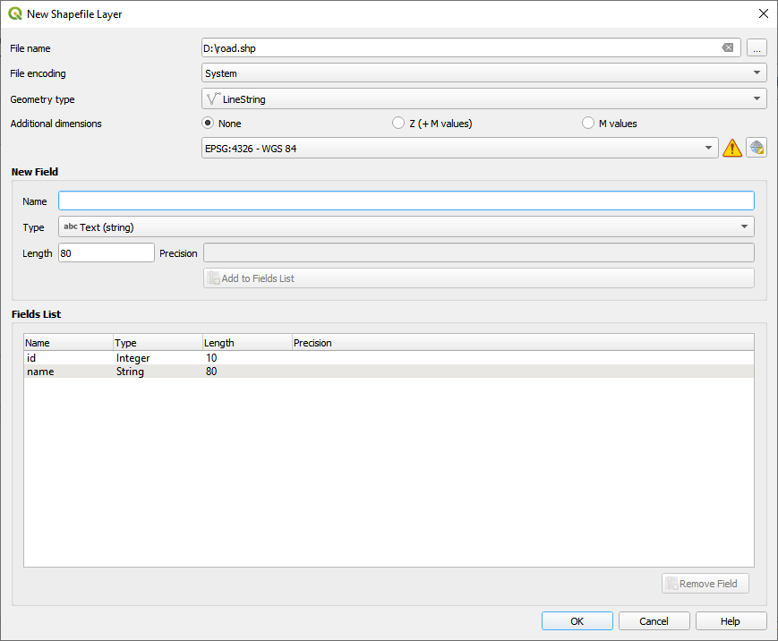

1. To plot road click on Add Line Feature. Click on the map where you want to draw line.

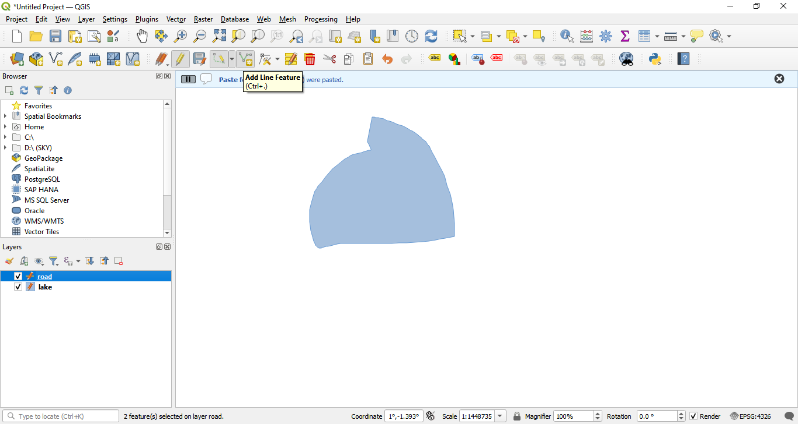

1. Once you are done then right click on map (Dotted line turn into solid line). Save your data –

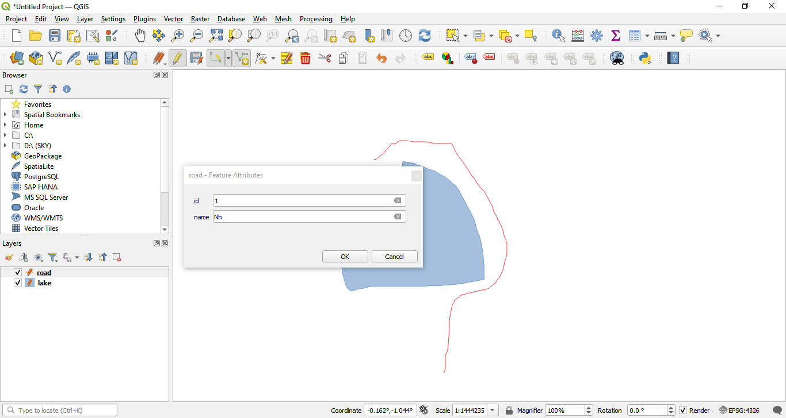

1. Set style for Roads in the same way as we have done for polygon

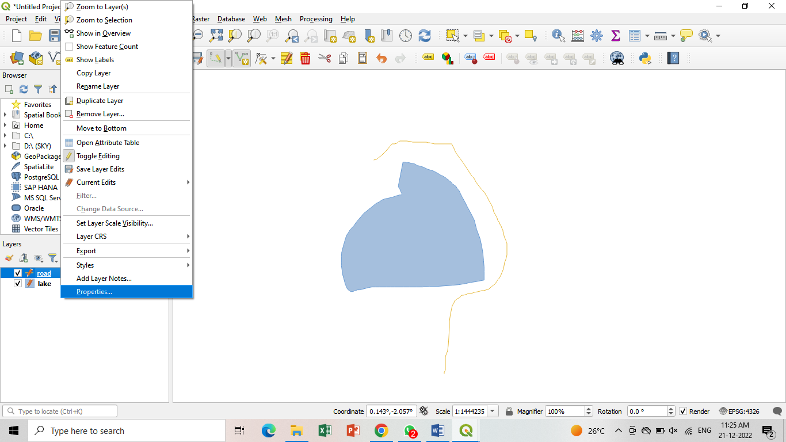

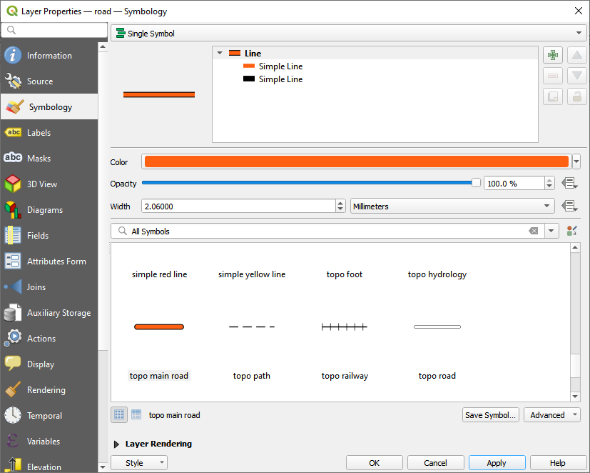

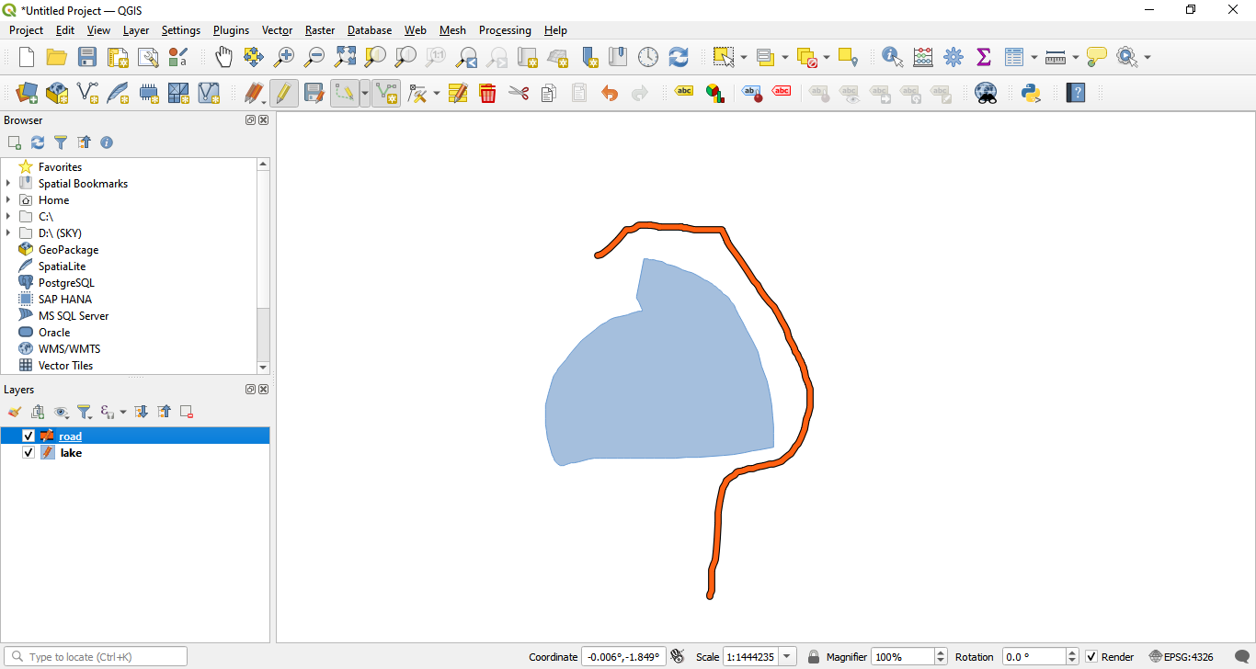

1. Add Labels –

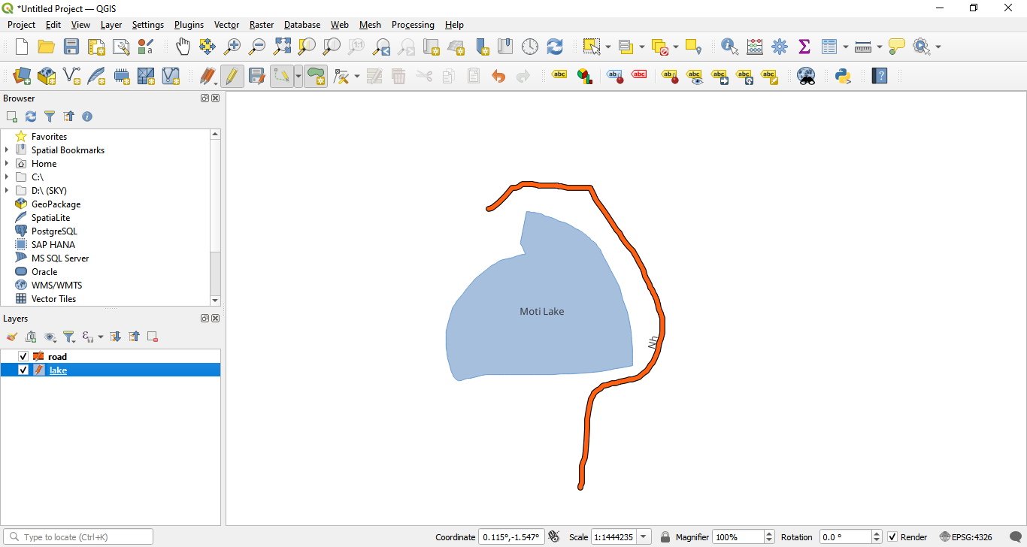

Date :21/12/22 Seat No:

…………………………………………………......

**PRACTICAL NO.1**

**Aim** :- Creating and Managing Vector Data: Adding vector layers, setting properties,formatting, calculating line lengths and statistics

**Practical –1C :- Creating Point Vector Layer**

1. **Create Point vector layer:**
2. Repeat same steps to add point layers as we have done in previous layers –
3. Select geometry type as Point –

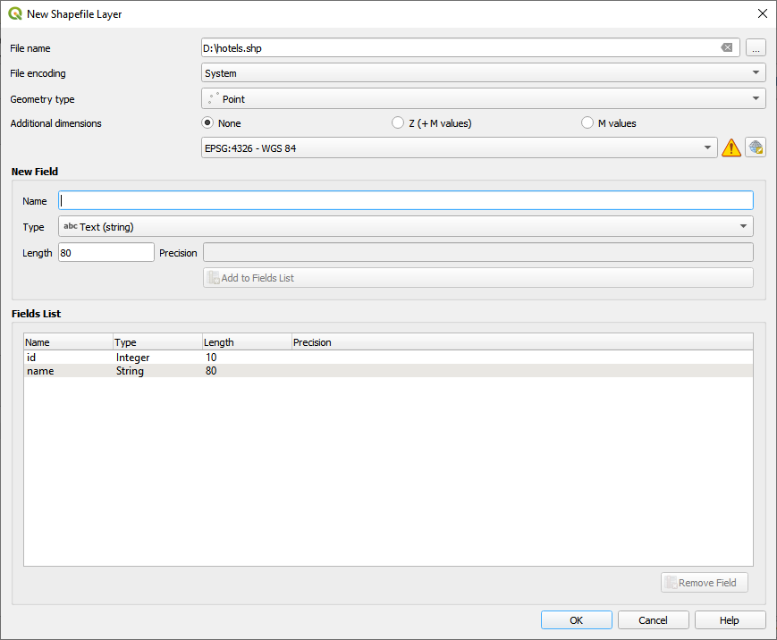

1. Select Properties by right clicking on Hotels Layer. Choose symbol and then click Ok -

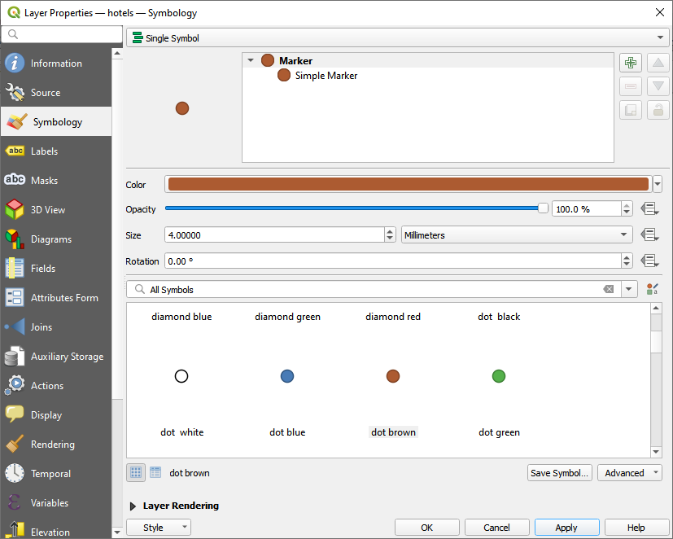

1. Add Labels -

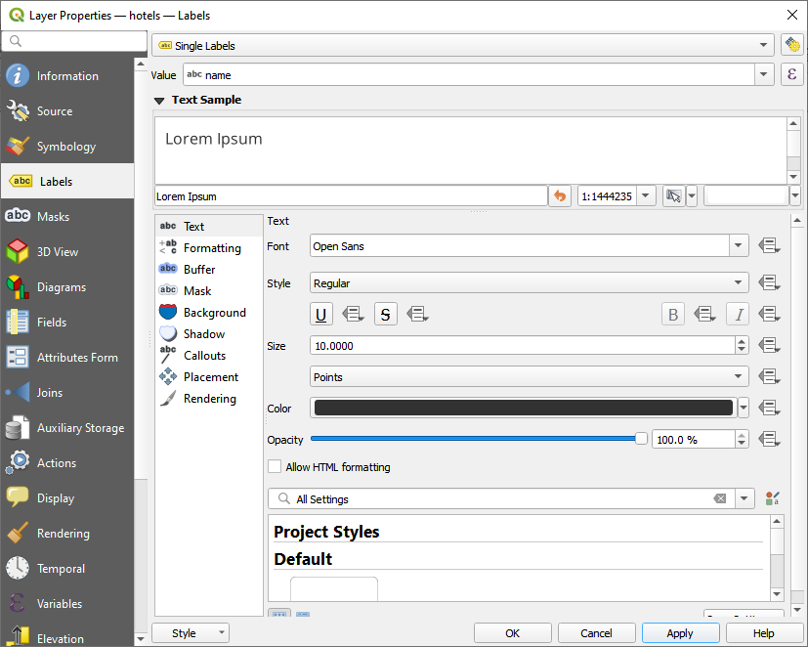

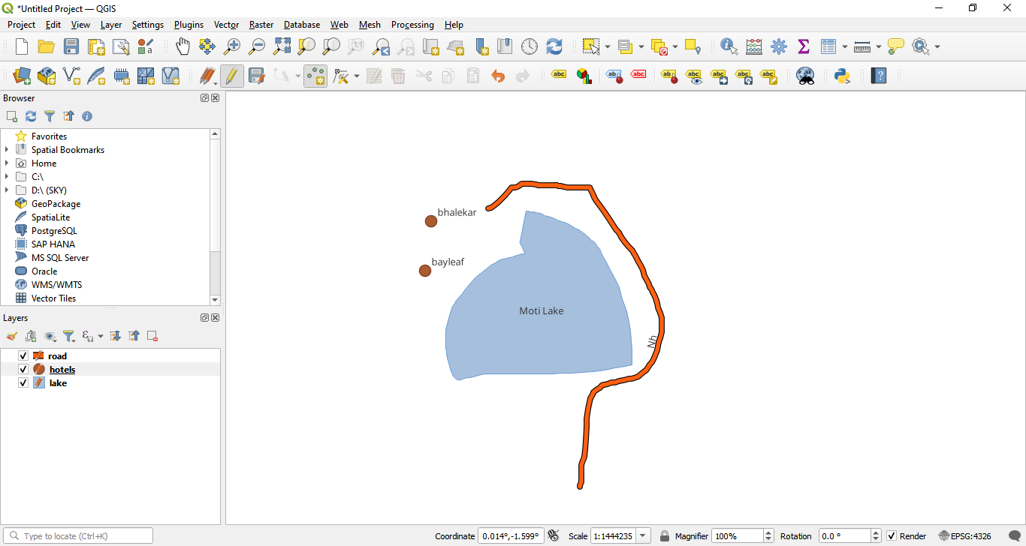

**Output –**

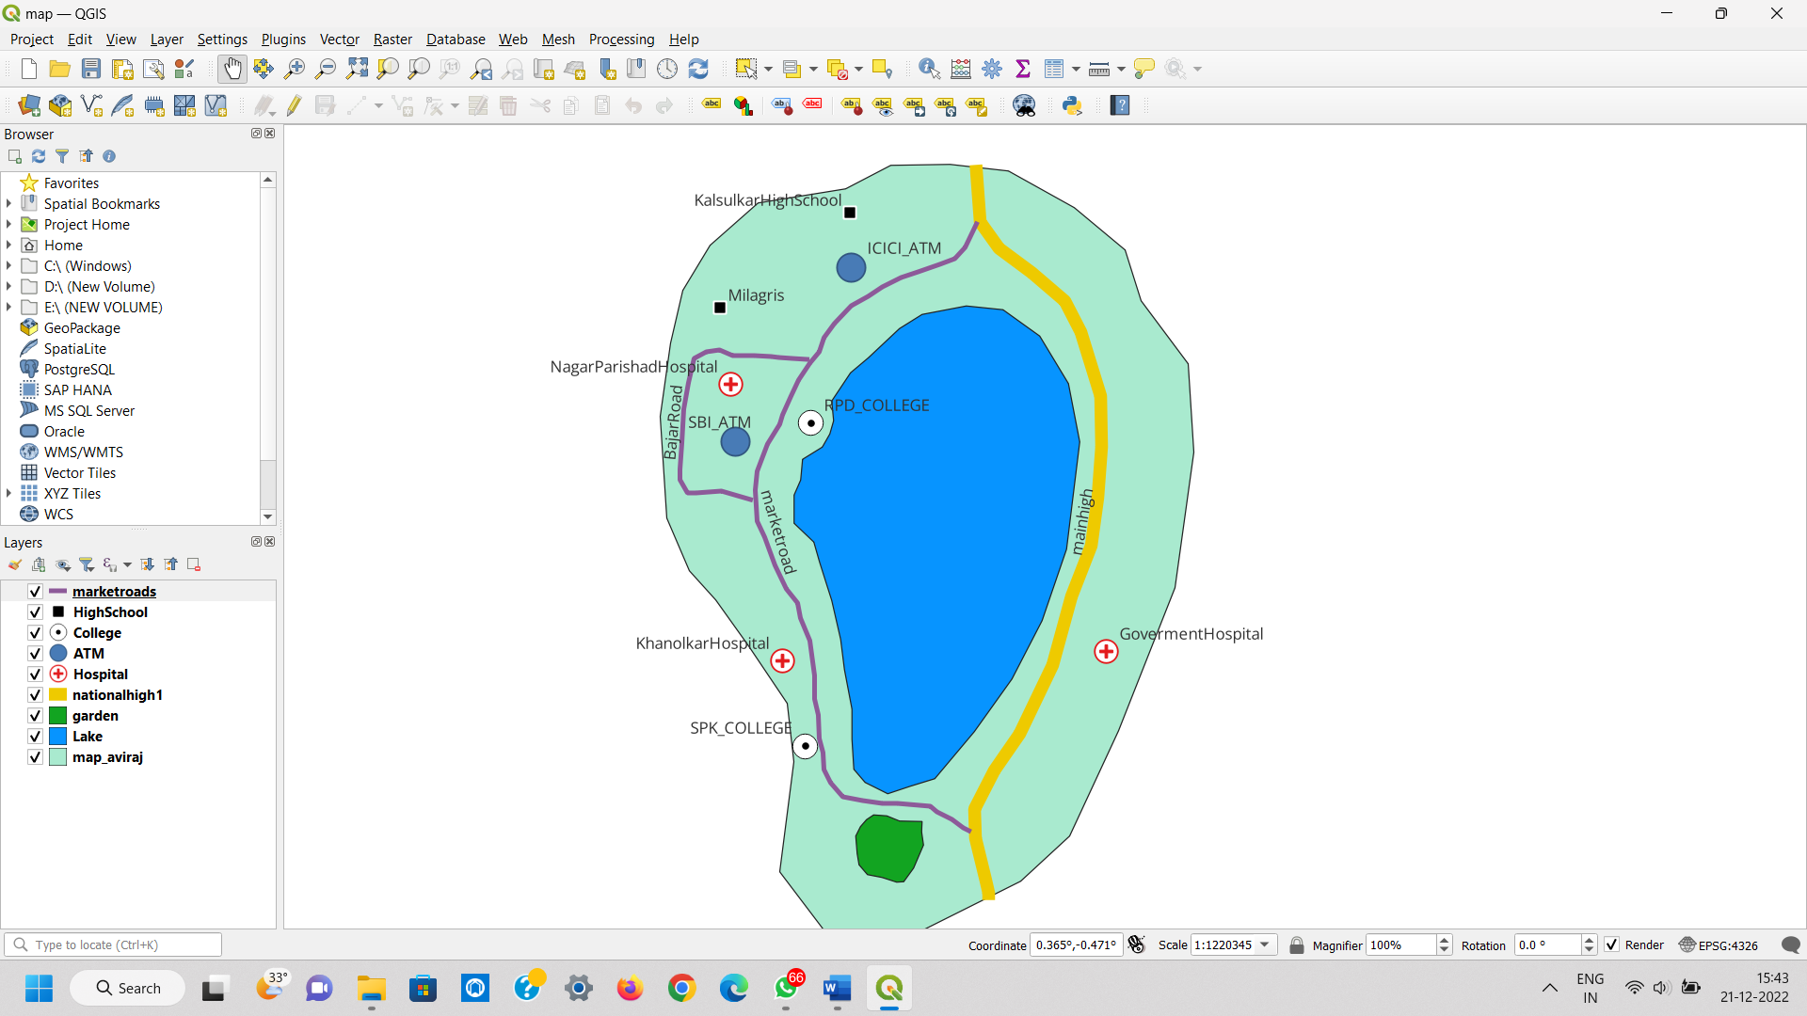

Date :21/12/22 Seat No:

…………………………………………………......

**PRACTICAL NO.1**

**Aim** :- Creating and Managing Vector Data: Adding vector layers, setting properties,formatting, calculating line lengths and statistics

**Practical –1D :-Calculate line length and statistics.**

1.Add new layer (Add vector layer).

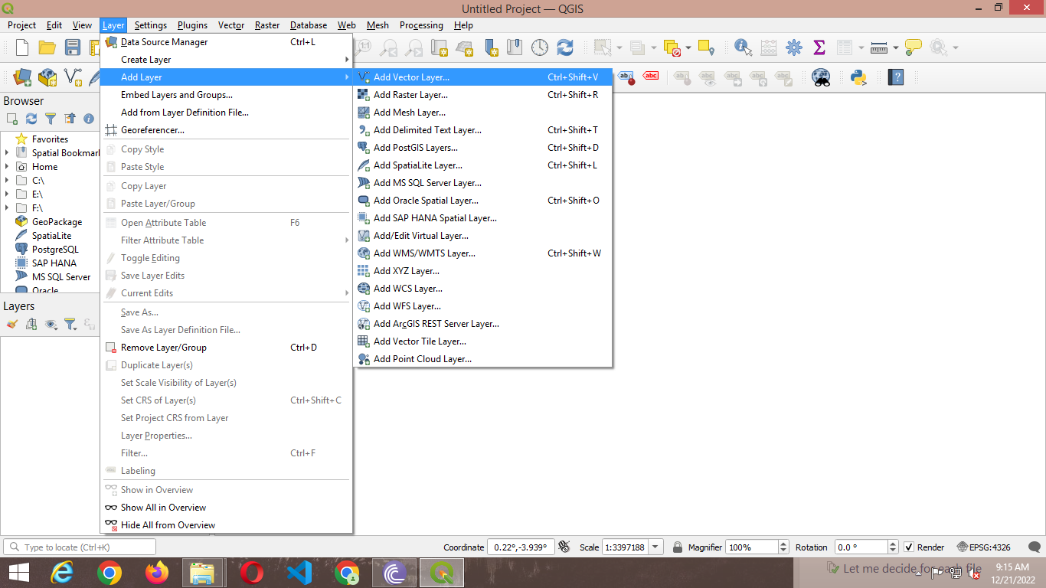

2.Extract files -> Select a Source -> select file IND_rails.shp for layer 1 in Vector dataset. .

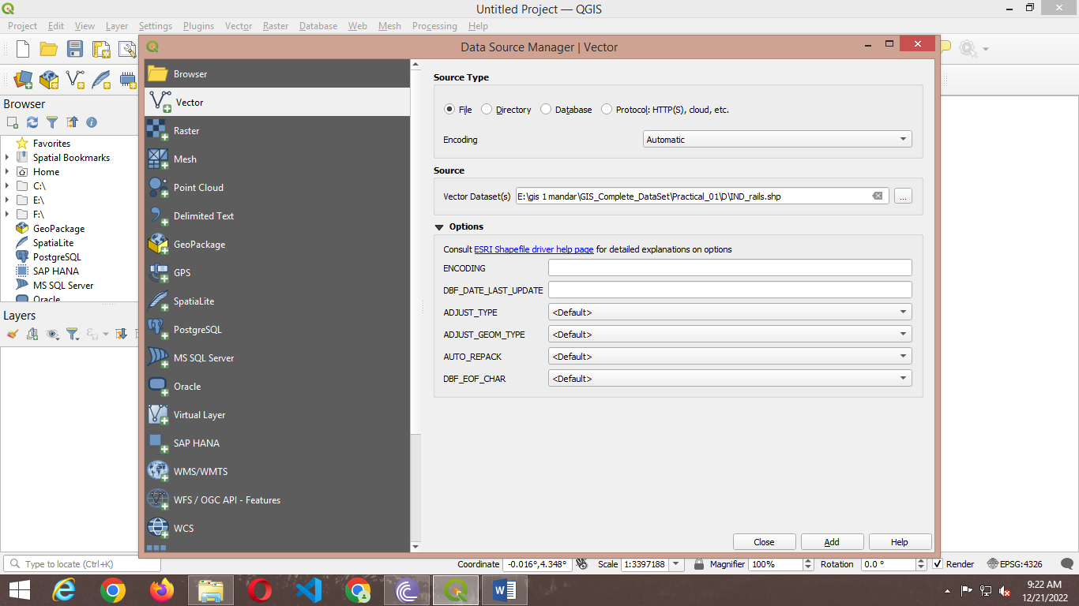

3.Extract files adm0 🡪Select a Source 🡪select file IND_adm0.shp for layer 2 in Vector dataset. .

4. select vector menu🡪Open attribute Table and then open field calculator.

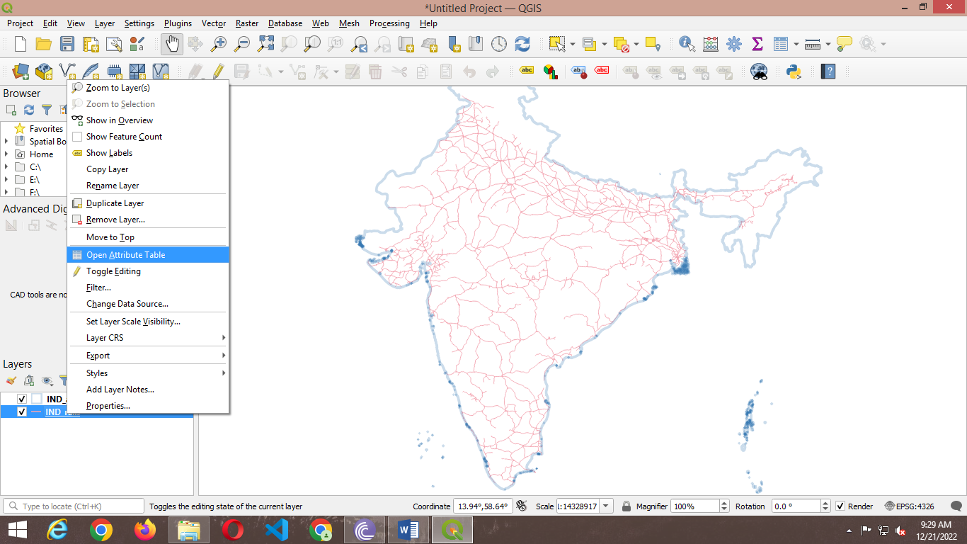

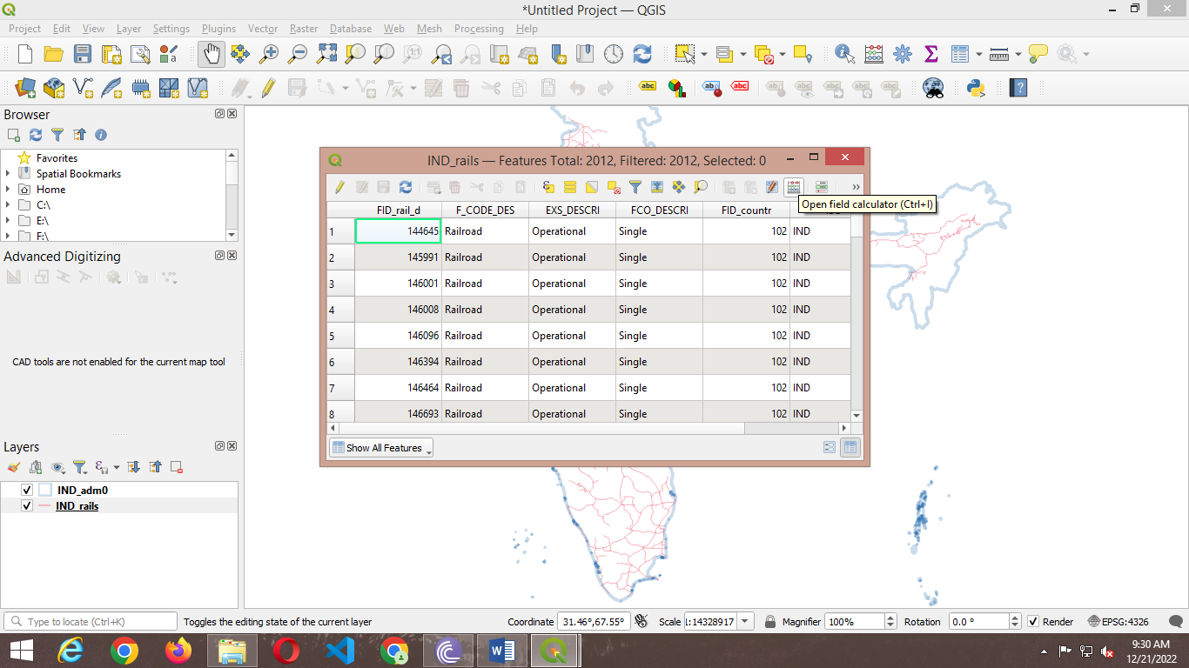

5.In Field calculator, select a geometry attribute and select Decimal Number in output field type.

From Function List search and type $length/1000.

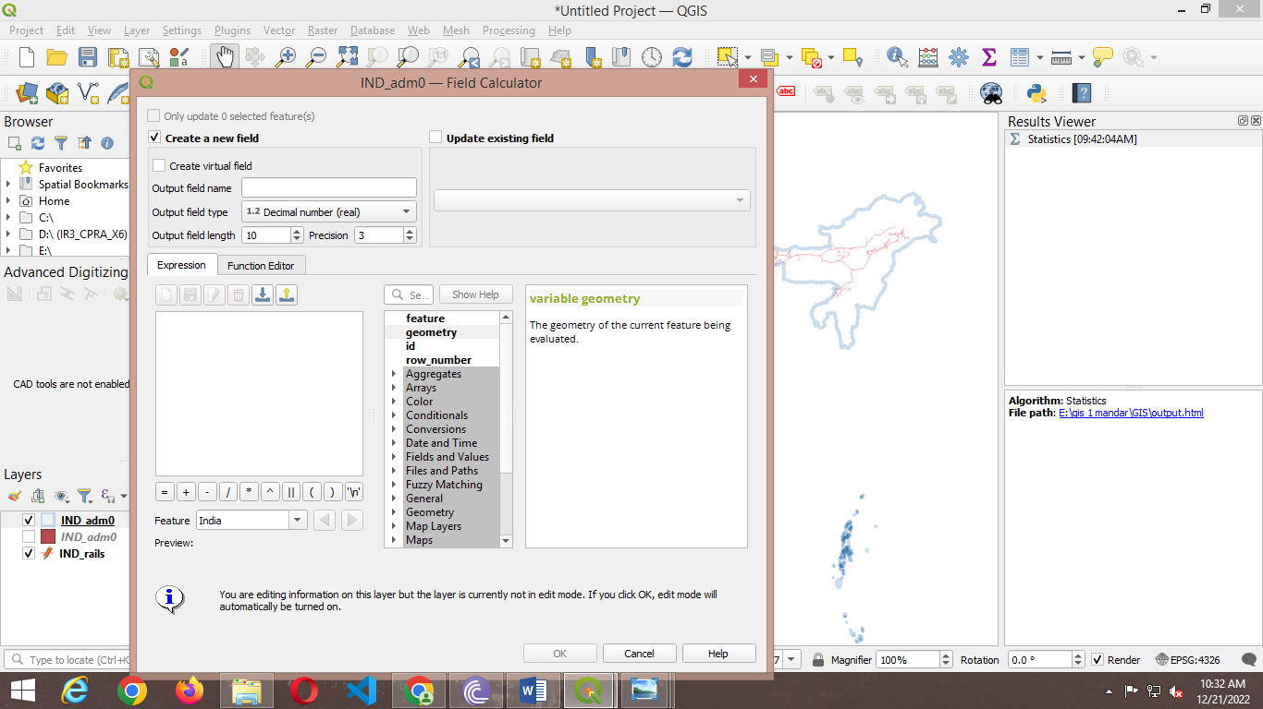

6.Open Analysis tools then select Basic statistics for fields. Press CTRL+S or click on Save Edits option on tool bar.

For calculating the total length of Railway tracks in India. ➢ Select Vector→ Analysis Tools→ Basic Statics for Fields.

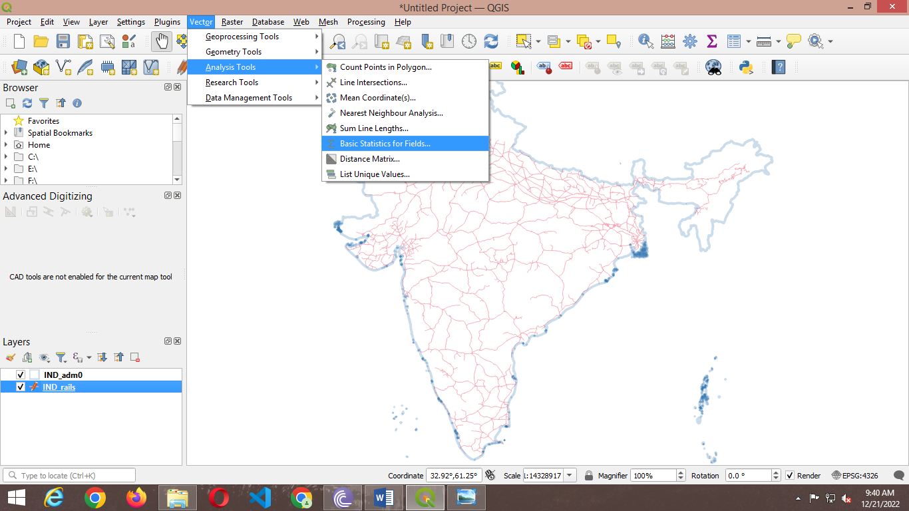

7.select a track length.

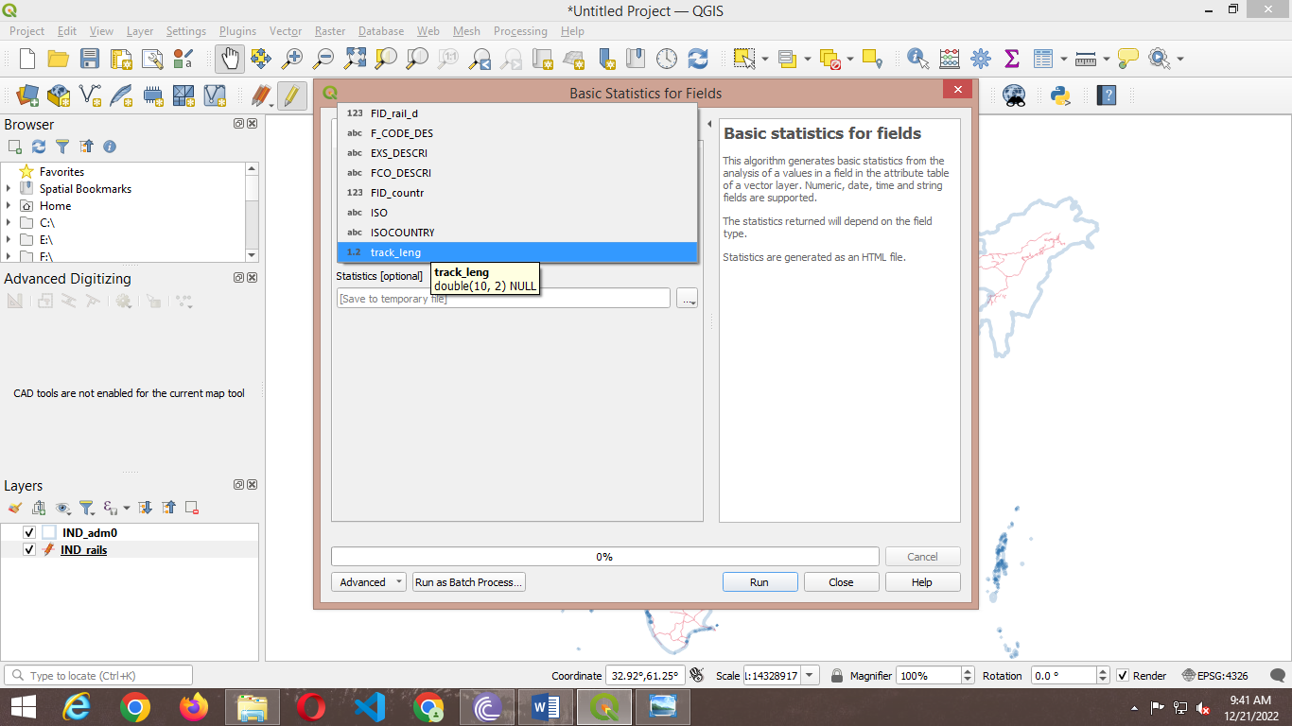

8. save html file in folder.

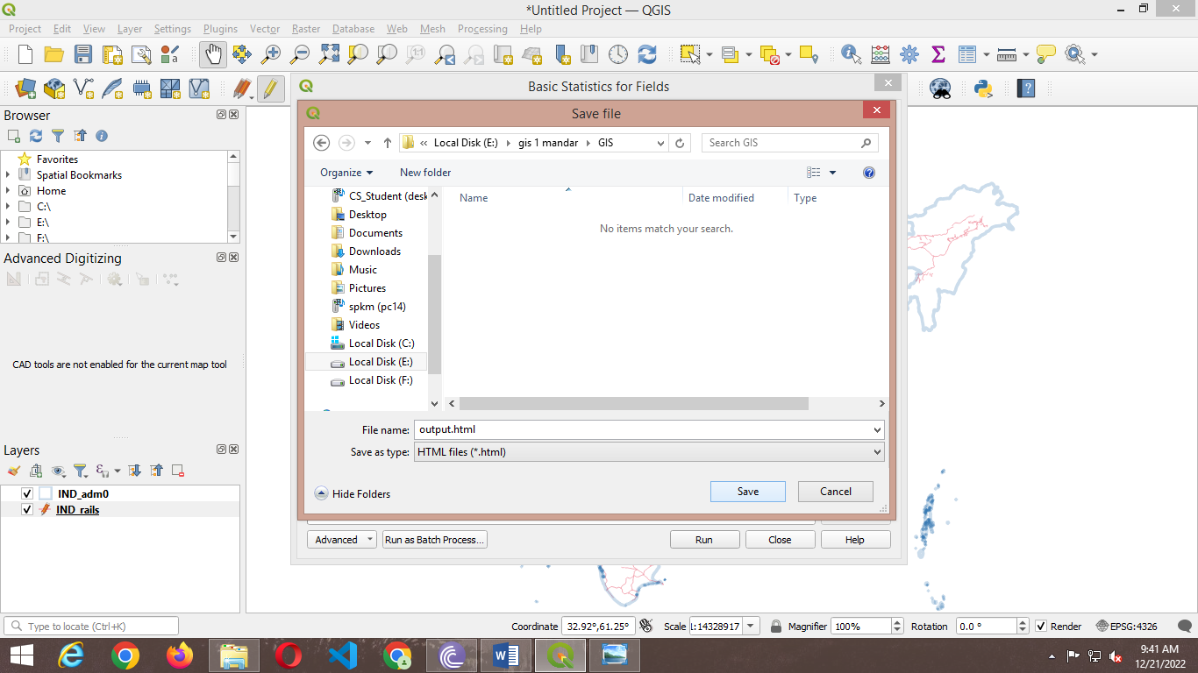

9.Press Run.

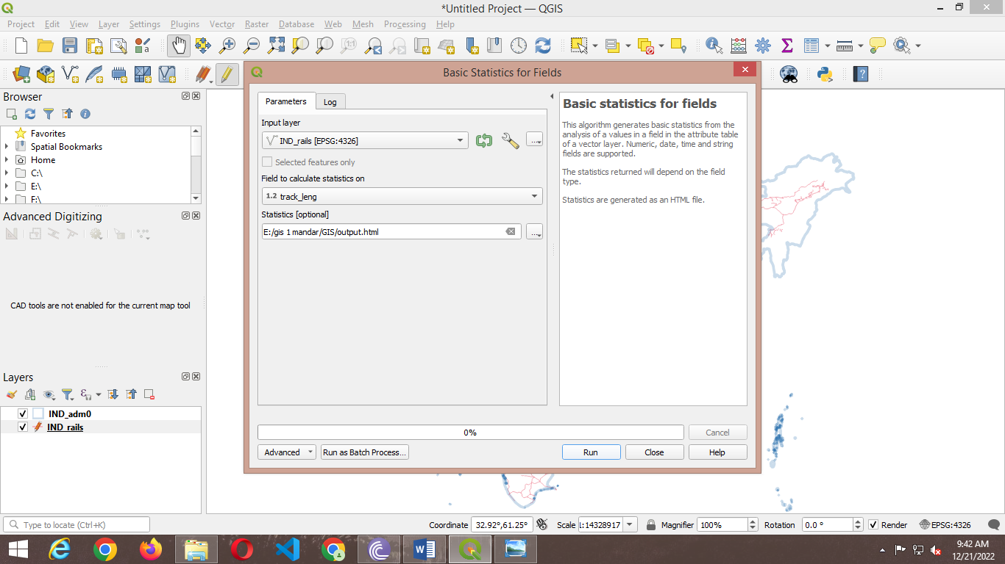

**OUTPUT :-**

